EXPERIMENT 1 - 15
EXP 1 :
OUTPUT:
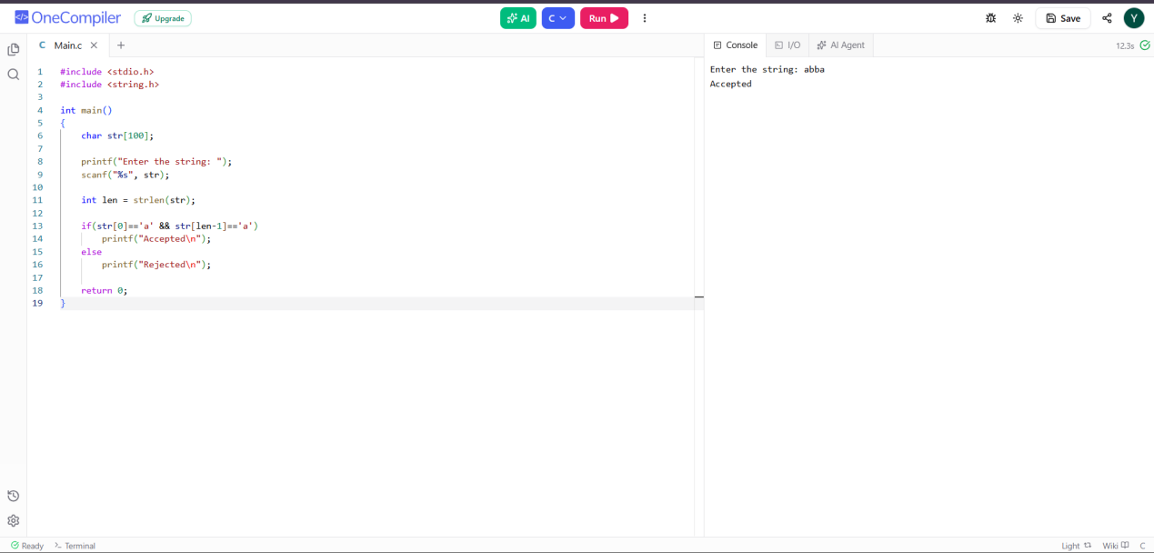
EXP 2:
OUTPUT:
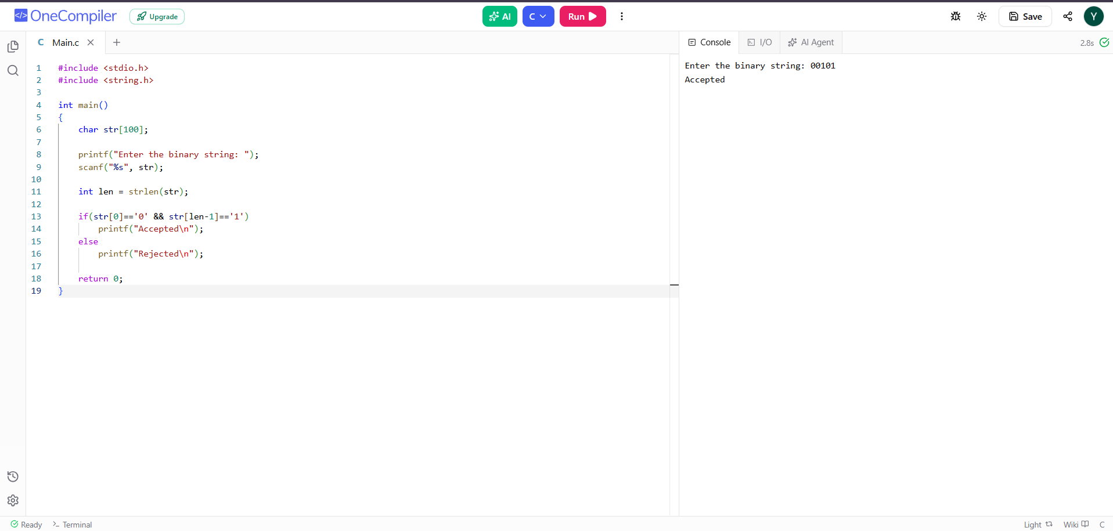

EXP 3:
OUTPUT:
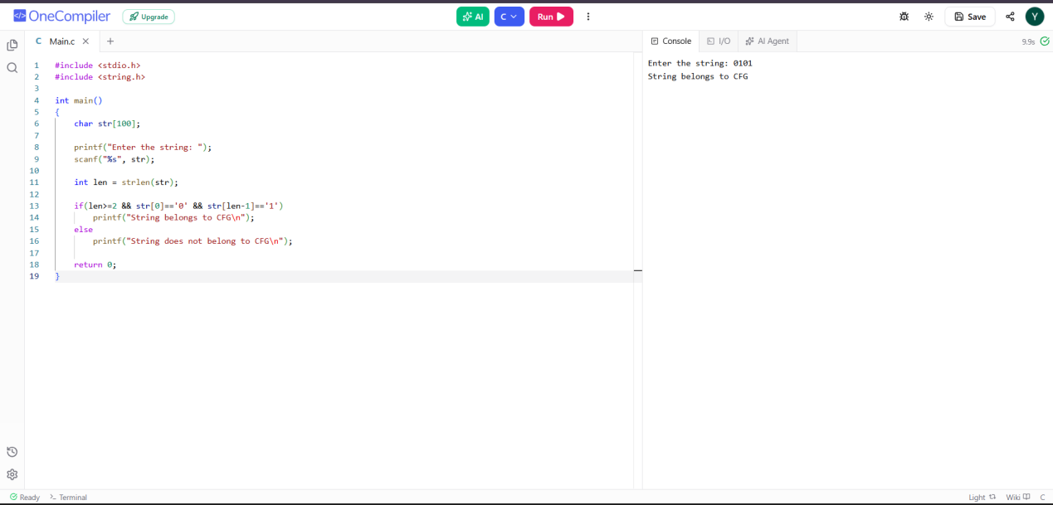
EXP 4:
OUTPUT:
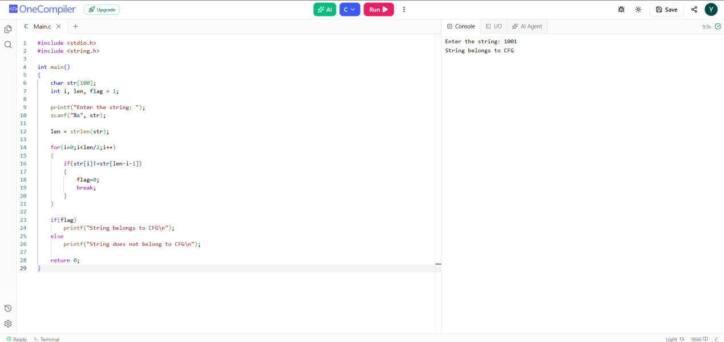

EXP 5:
OUTPUT:
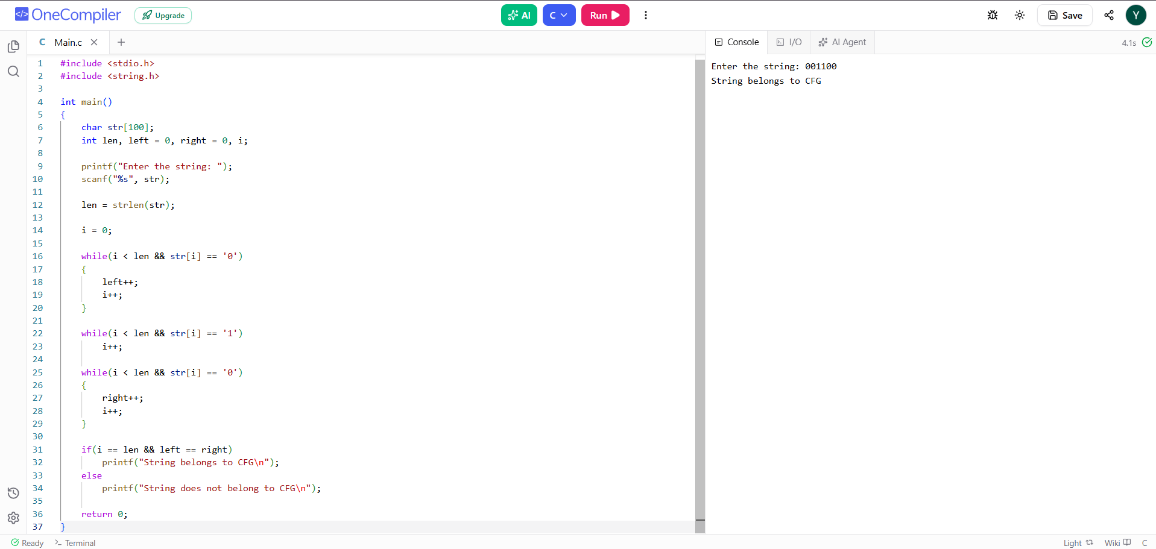
EXP 6:
OUTPUT:
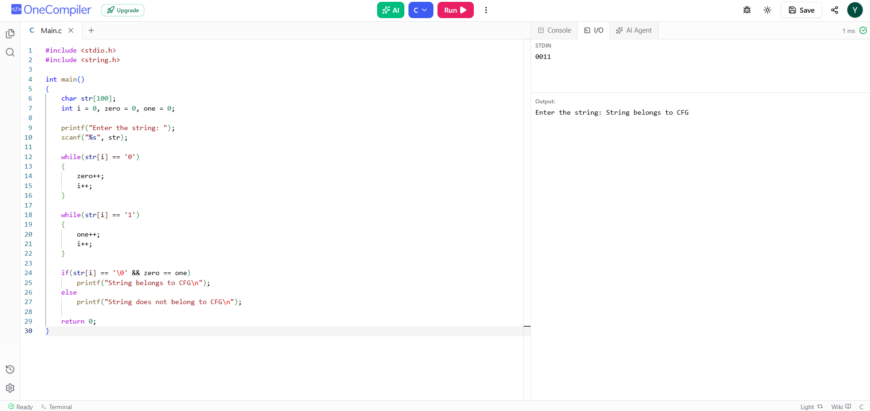
EXP 7:
OUTPUT:
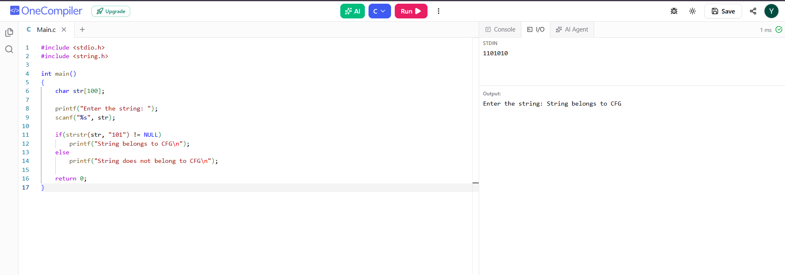
EXP:8
OUTPUT:
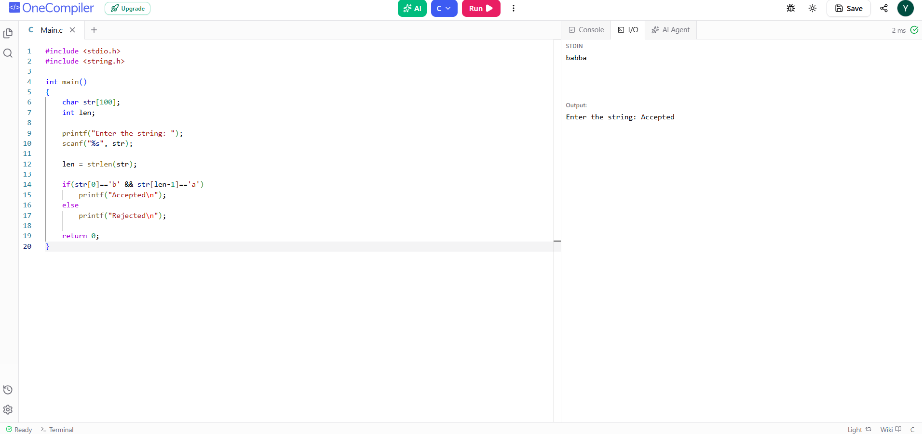
EXP:9
OUTPUT:
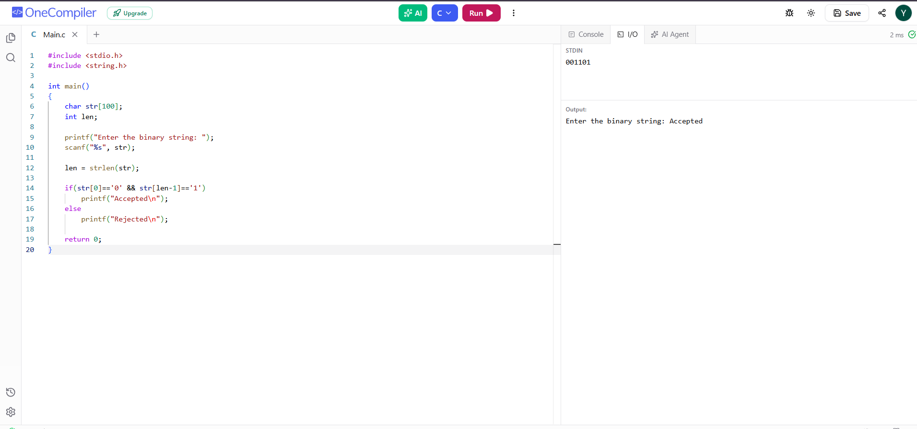
EXP:10
OUTPUT:
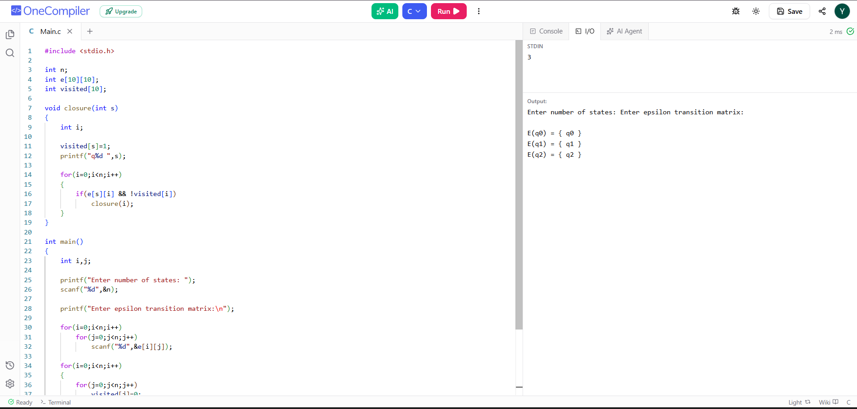
EXP 11:
OUTPUT:
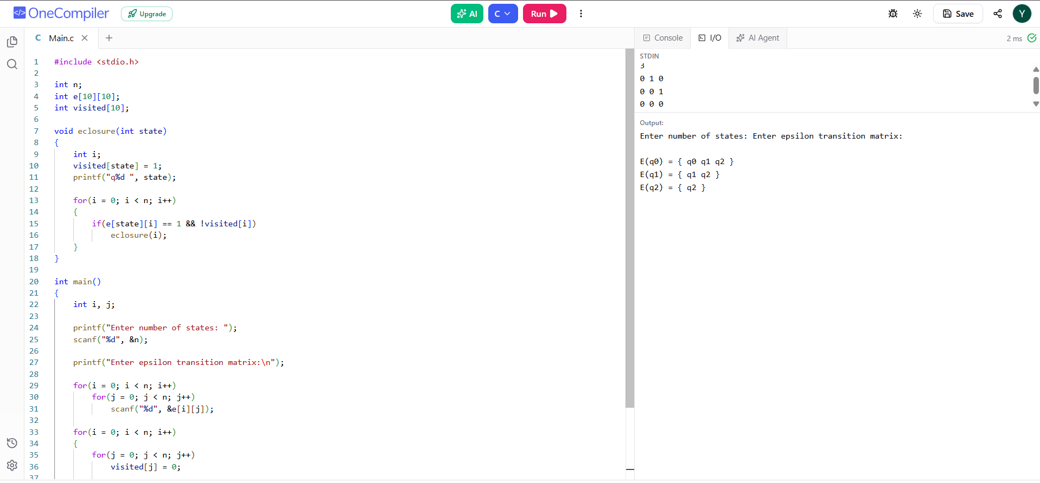
EXP:12
OUTPUT:

